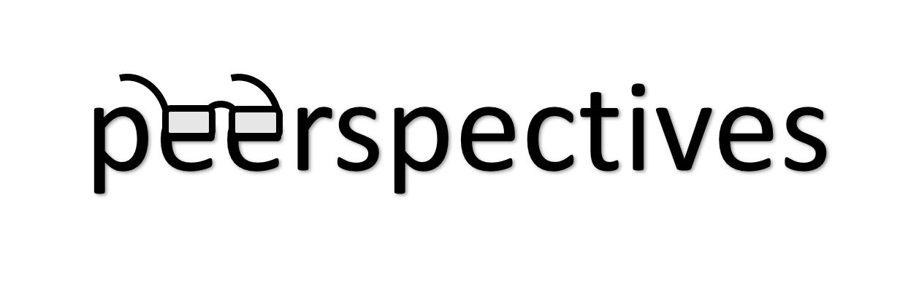

**Confidentiality Agreement**

**Peer Review and Biomedical Editing Training Initiative Students**

I, , agree to participate in the

Peerspectives course and take part in the reviewing of live scientific manuscripts submitted to the BMJ. **I certify that I will keep confidential** any information about articles that are assigned to me to review in accordance with the requirements for reviewer published by the BMJ1. Furthermore, **I will not upload any unpublished manuscripts**, in whole or in part, undergoing review at BMJ Journals (or any information about them) into publicly available AI tools where the security of the confidential information cannot be guaranteed. If I use AI technology to improve word processing and language, I will declare this explicitly when submitting my reviews. **I further agree to follow the ethical guidelines** for peer reviewers as proposed by the Committee on Publication Ethics2.

Place, Date, Signature of Participating Student

1. https://www.bmj.com/about-bmj/resources-reviewers

2. COPE, https://publicationethics.org/